|  |  |
| --- | --- |
|  | **YEAR 12 MATHEMATICS SPECIALIST**  **SEMESTER TWO 2016**  **TEST 3: Derivatives and Integrals** |

Name: _______________________

Monday 15th August Time: 45 minutes Mark /40

Section 1 – Calculator free 20 marks

### [4 marks]

A curve is defined by the equation 

Use implicit differentiation to determine the equation of the normal drawn at the point.

### [3 marks]

Determine the area enclosed by the curves  and , as shown.

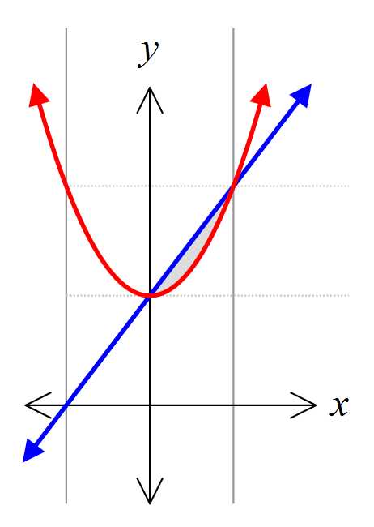

### [13 marks – 4, 1, 4 and 4]

Determine each of the integrals given

1.  by using a suitable substitution
2. 
3. 
4.  in the form 

Section 2 – Calculator assumed 20 marks

### [3 marks]

Determine the volume generated when the region enclosed by the curves  and , as shown, is rotated around the *x*-axis.

### [5 marks – 2, 2 and 1]

Fluid flow through a narrow pipe has been modelled by the equation  where *F* is the flow, *k* a constant and *r* the radius.

1. How will the rate of flow change if the radius is increased by 44%?
2. Use the incremental technique to estimate the change of radius that produces a 10% decrease in flow.
3. Is the incremental technique appropriate in (a)? Explain.

### [7 marks – 4 and 3]

#### A baseball diamond consists of a 25 metre square.

#### A batter goes from the home plate and runs directly towards first base at 8 metres per second.

#### How fast is his distance from second base changing when he is half-way to first base?

#### How is angle θ changing at the same instant?

### [5 marks]

#### Calculate the exact volume generated when the region contained between and for is rotated about the *y*-axis.